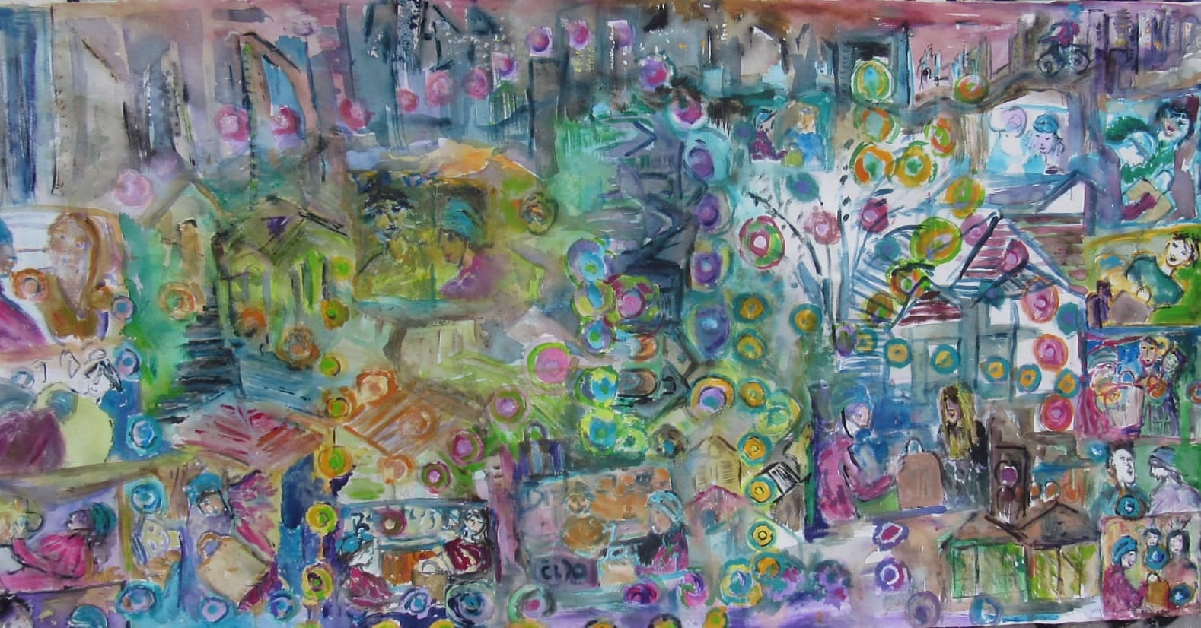
Title: 'the deliverer', 2020
Medium: acrylics on canvas
Dimensions: 197X100 cm

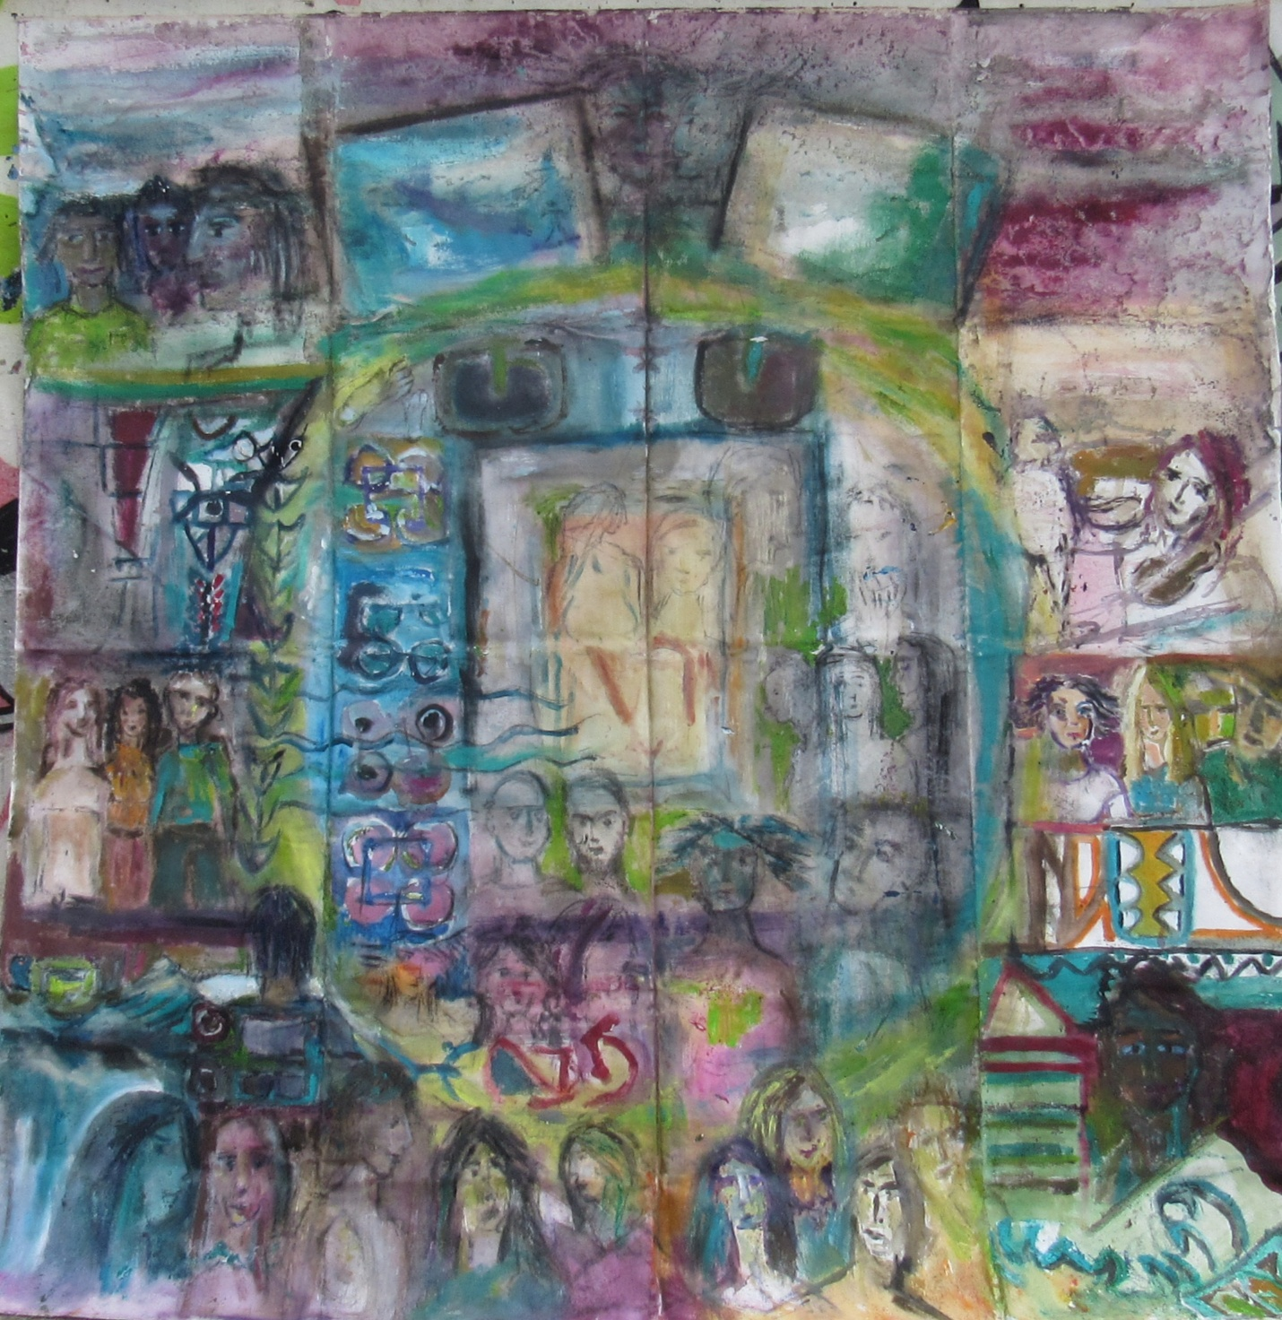

Title: 'lockdown in hostel', 2020
Medium: acrylics on canvas
Dimensions: 193X193cm

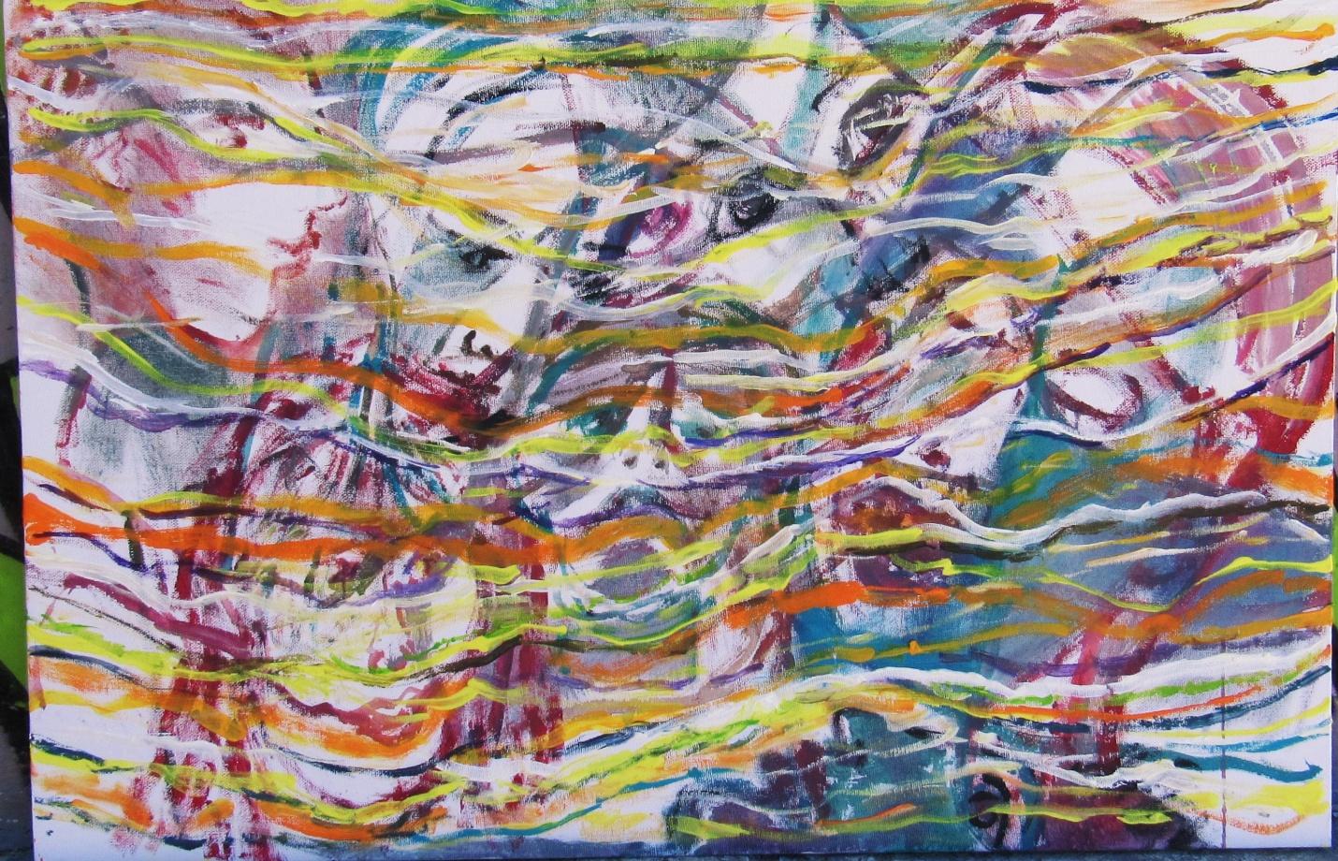
Title: interneted selves, 2020
Medium: acrylics on cardboard canvas
Dimensions: 50X77cm

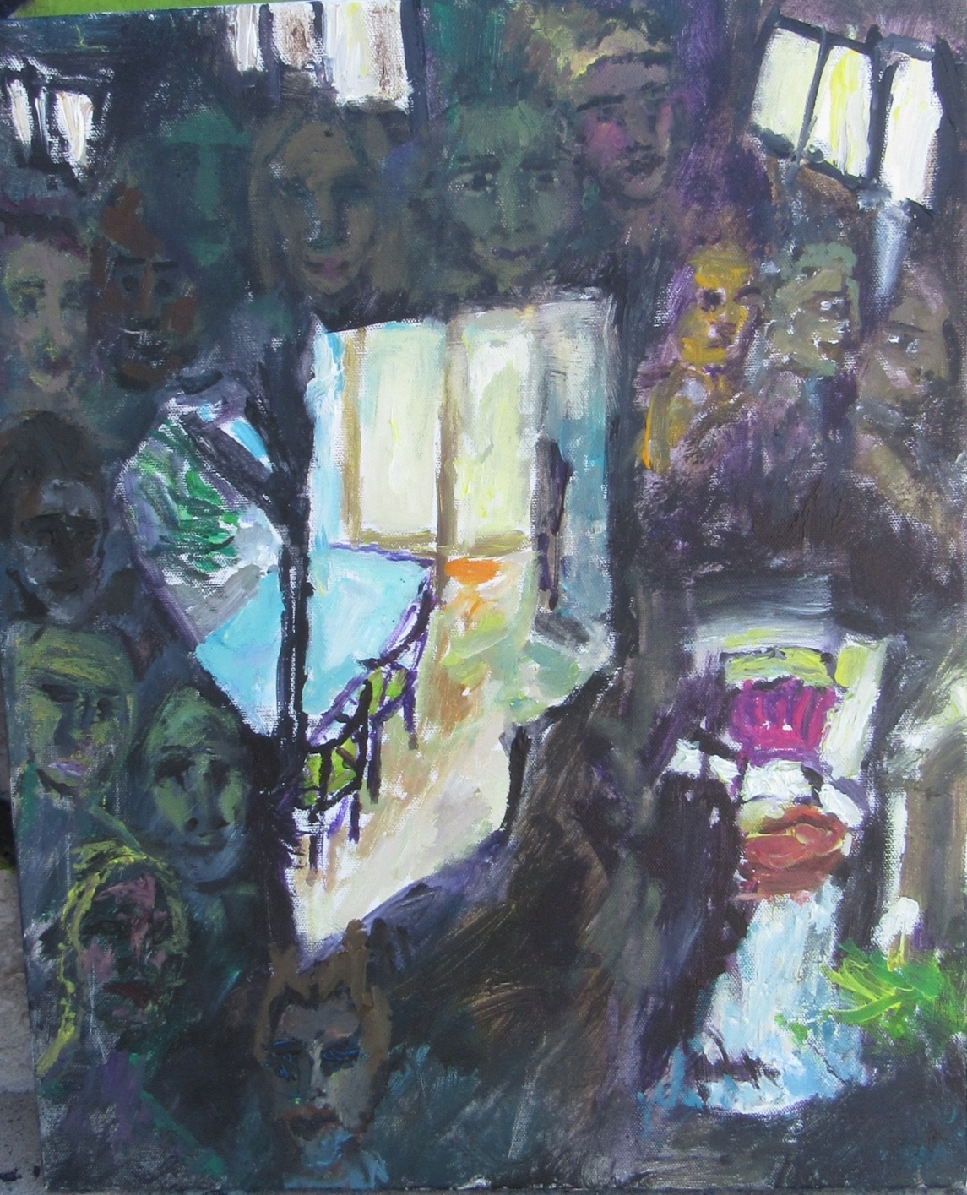
Title: settled and haunted, 2020
Medium: acrylics on canvas
Dimensions: 50X40cm

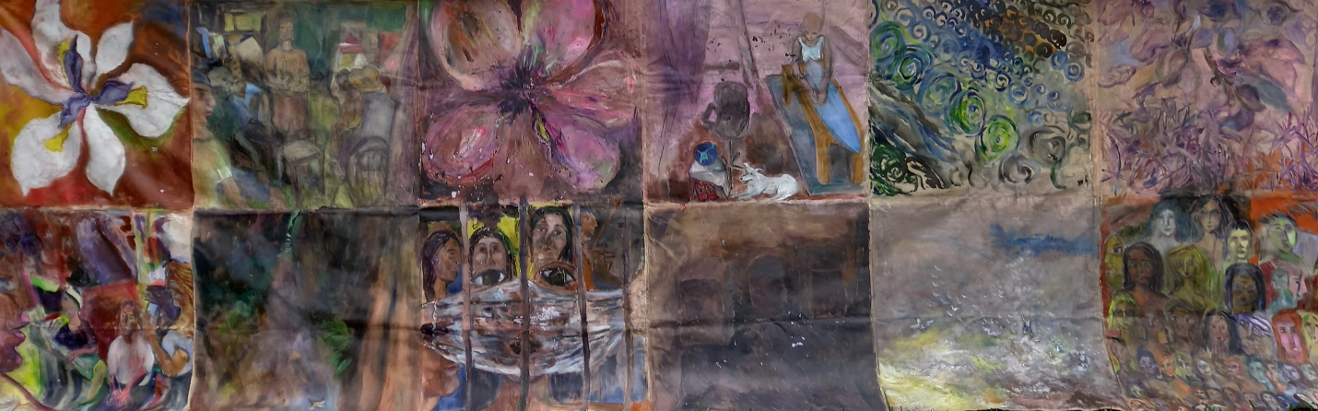
Title: lifebits, 2021(unfinished)
Medium: acrylics on canvas
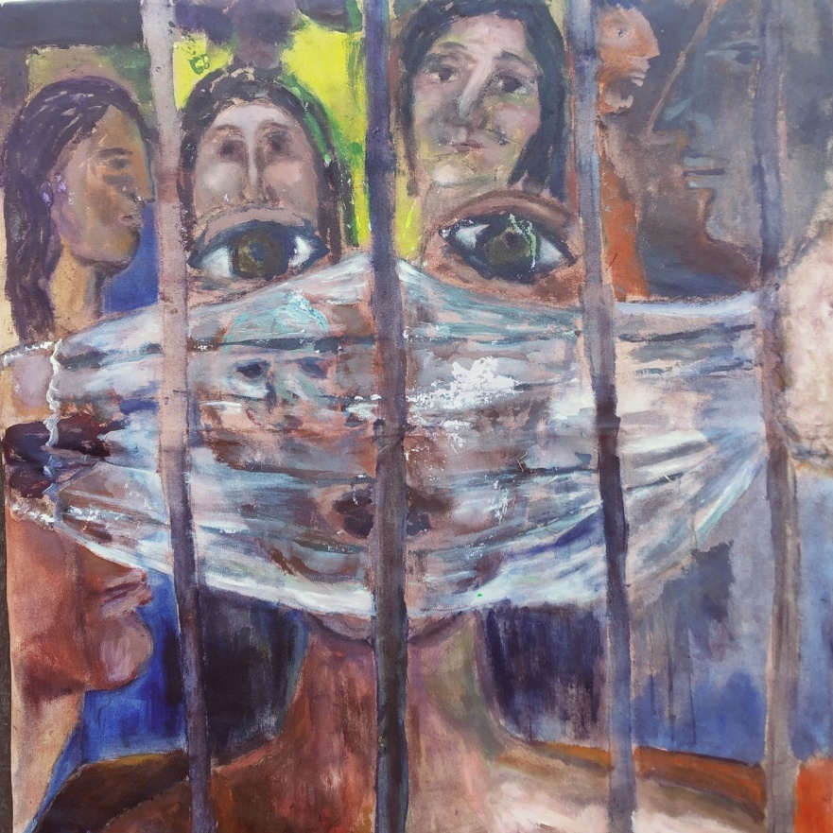
Dimensions: 522X184cm

Title: masked selves, 2021
Medium: acrylics on canvas
Dimensions: 87X92cm

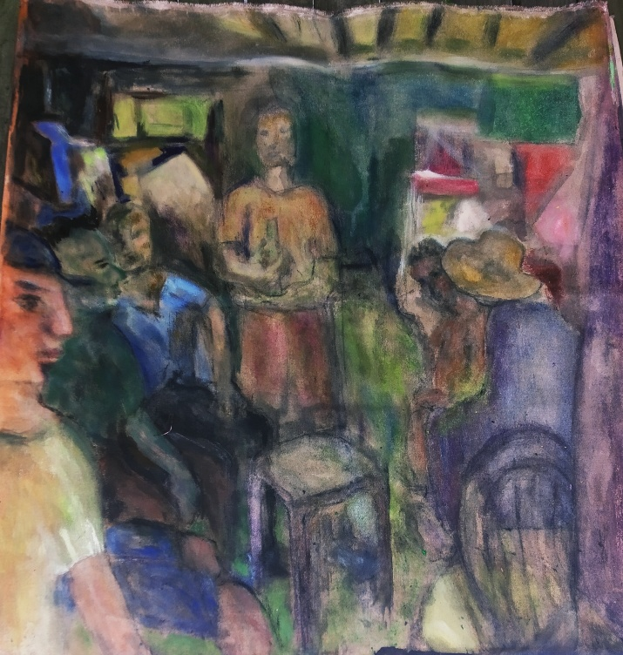
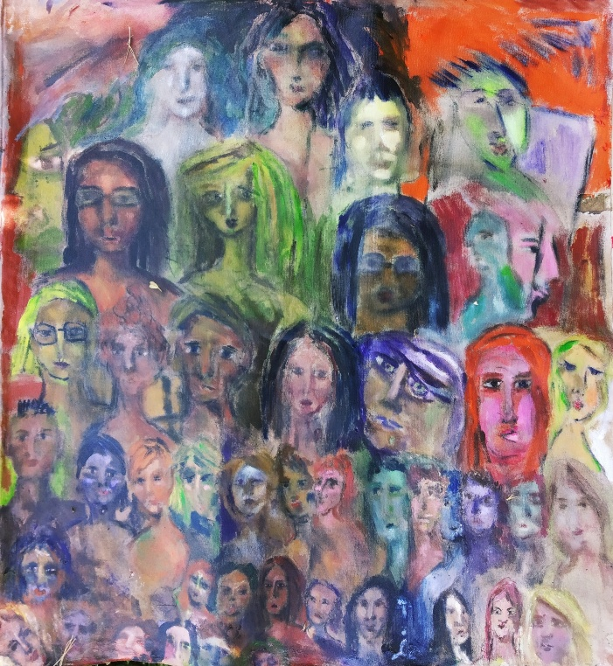
Title:art world,. 2021 Title: garage life, 2021
Medium:acrylics on canvas. Medium: acrylics on canvas
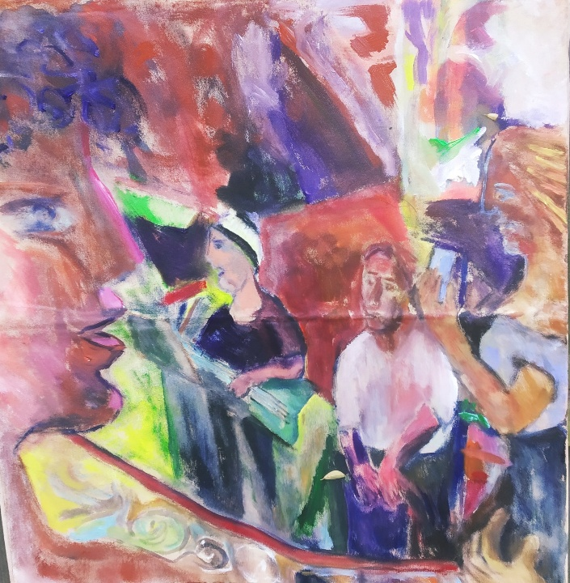
Dimensions:95X87cm. Dimensions: 95X87c
Title: les musicians, 2021
Medium: acrylics on canvas, dimensions: 95X87cm
OLDER WORK

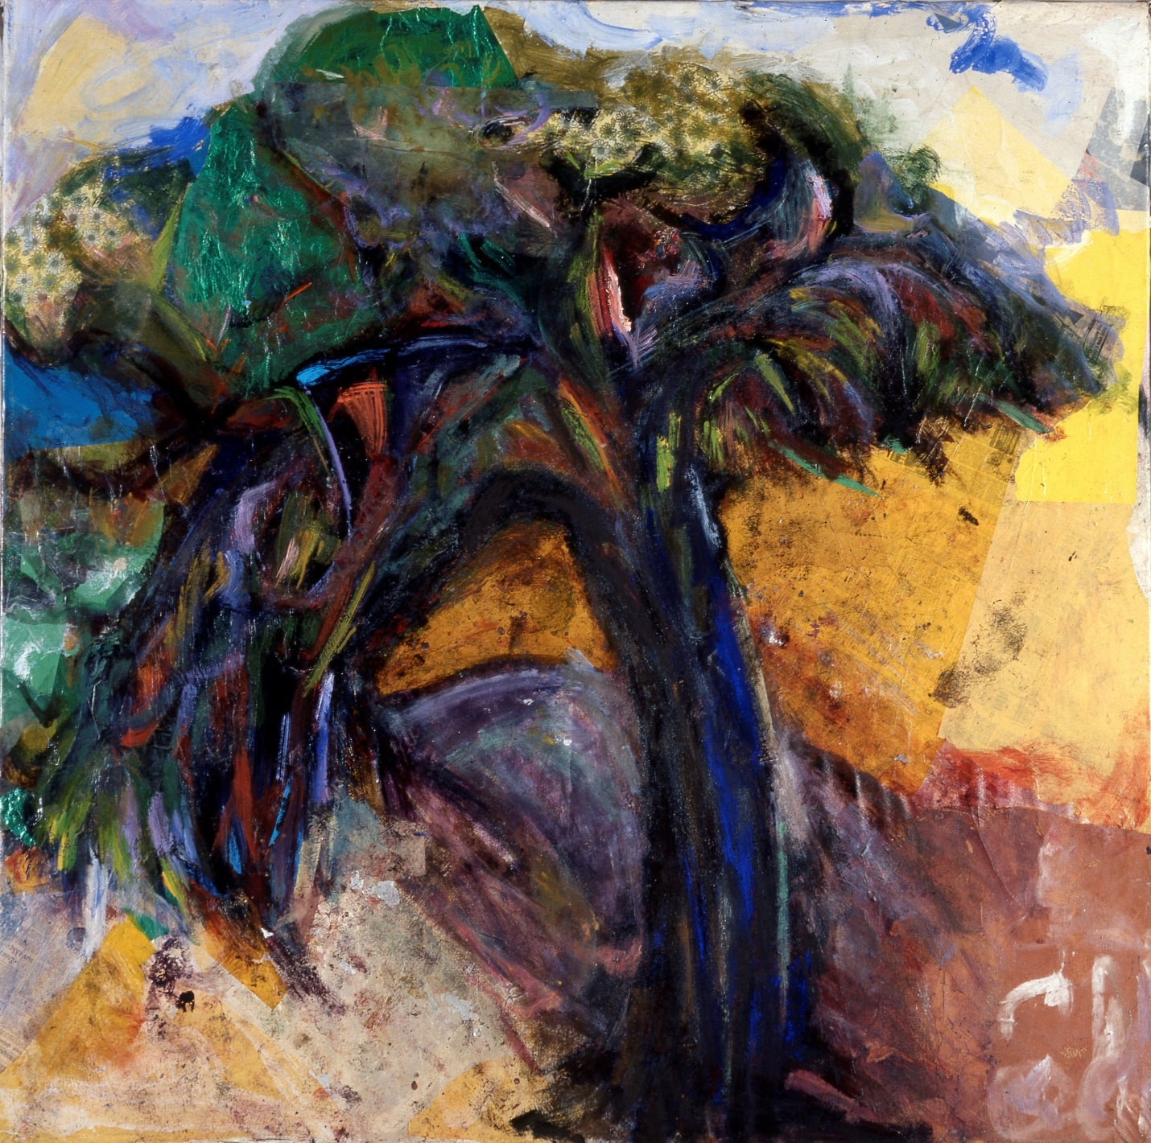
Title: heavy tree, 1995, medium: collage and acrylic paint on canvas Dimensions: 198X197cm

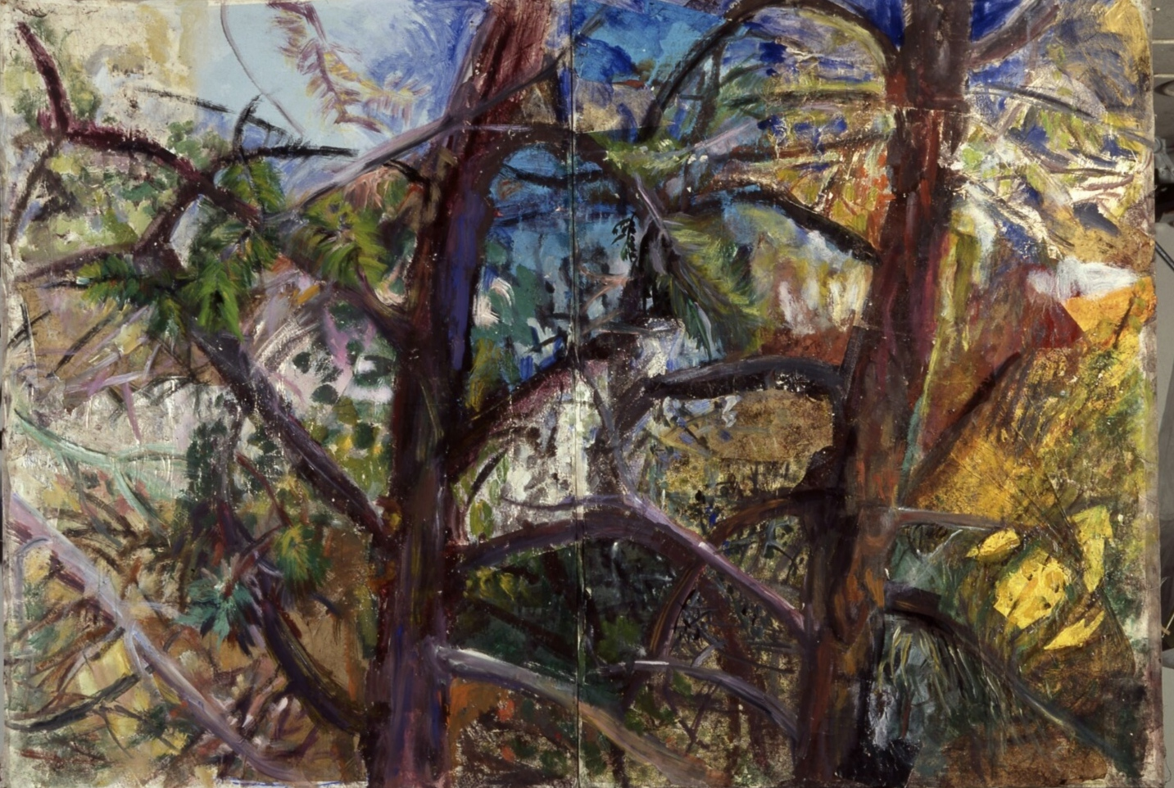
Title: two trees in dialogue, 1995, medium collage and acrylics on canvas, dimensions: 320X200cm

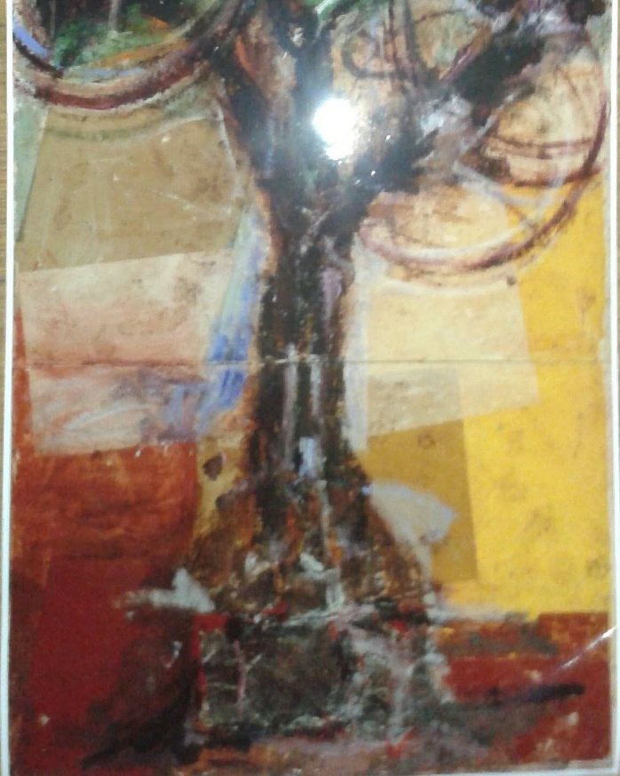
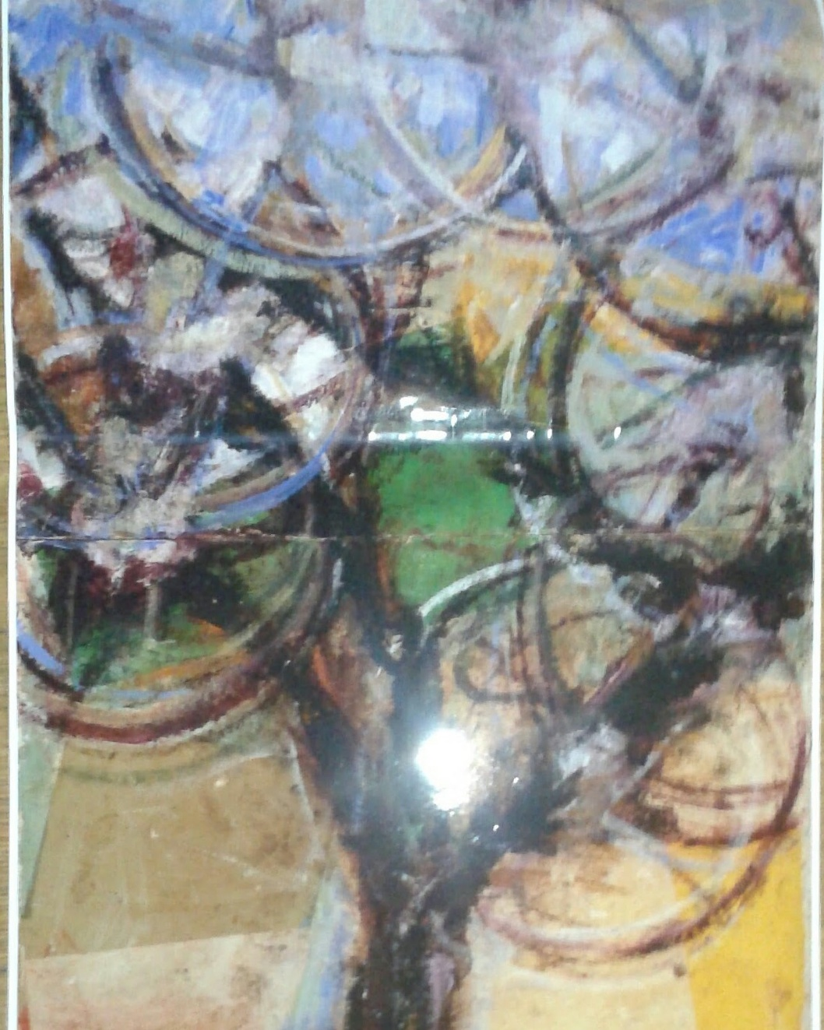
Title: Tall tree, 1996 Medium:collage, assemblage, acrylic paint on canvas, Dimensions:400X160cm
FURTHER ABSTRACTION
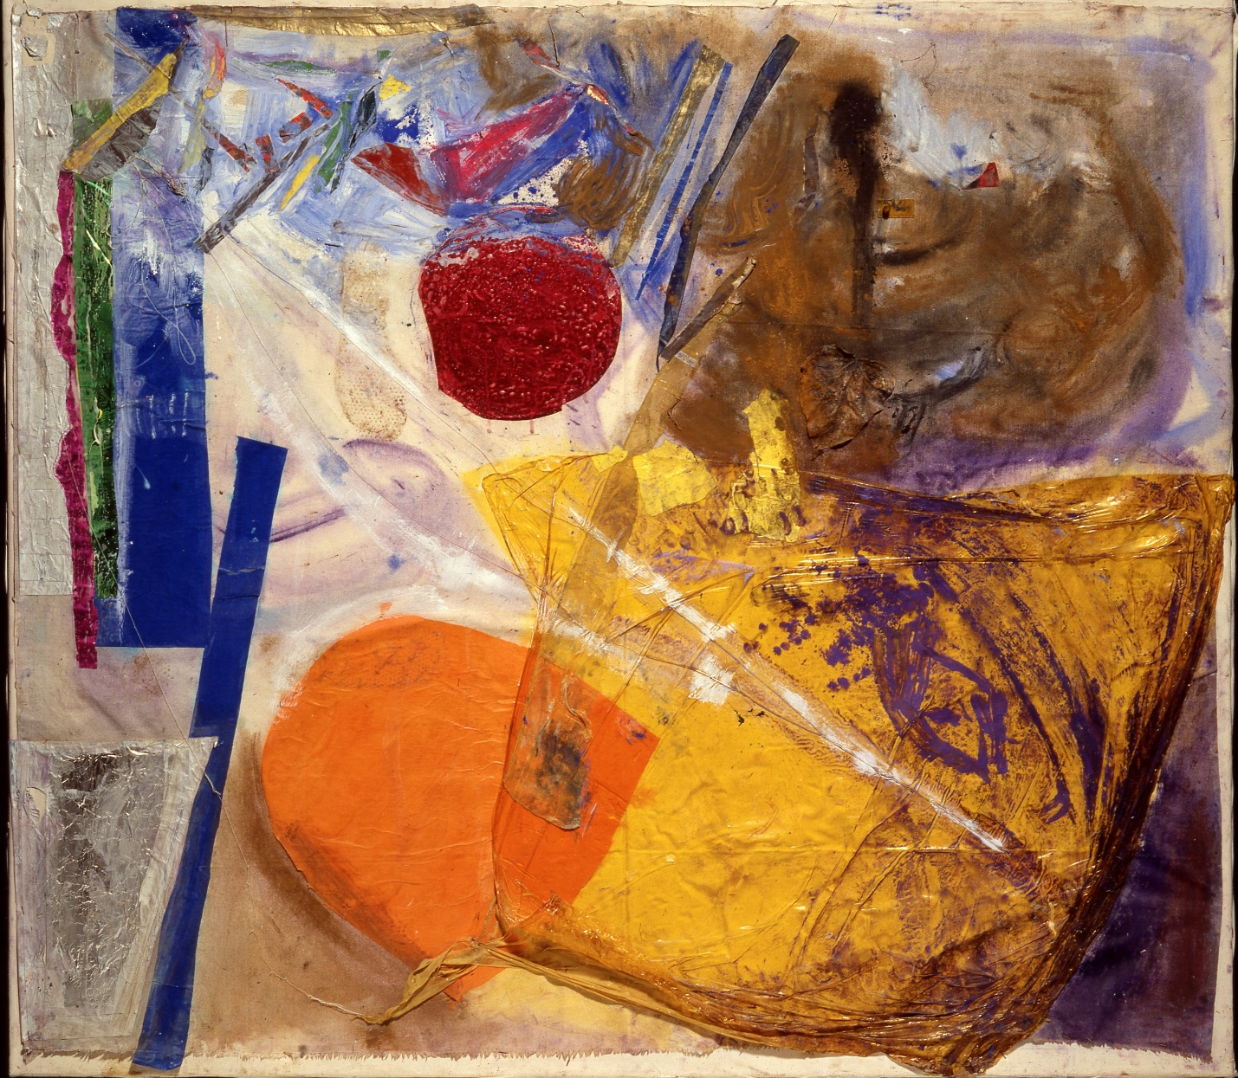
Title: Untitled , 1997,Medium: Collage and acrylic paint on canvas, Dimensions: 140X160cm
See more on website: www.myartinaction.yolasite.com , (also CV, Artist statement, link toy YouTube channel).
Recent and current work on instagram: #chatigiannakiathina
Contact info: email: athinachatzigiannaki1@gmail.com
Australian phone: 0061 406053516
European: 00306938373881

